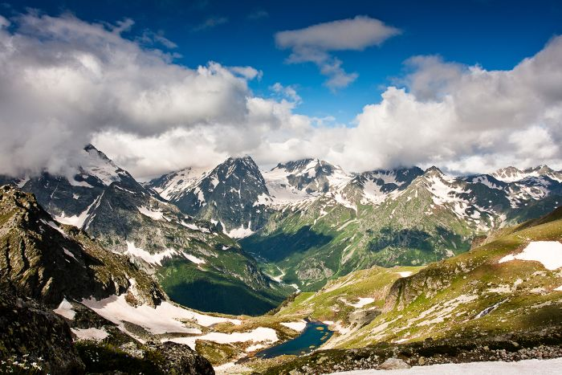
МКОУ «Гадаринская СОШ»

Стихотворение

« Welcome to Daghestan»

Сочинил:
ученик 8 класса
Саидов Сайгидпаша Каримулаевич
Руководитель:
учительница английского языка
Тажуева Жанета Тажудиновна

Новое Гадари 2016

MSCI «Gadary school».

The poem

« Welcome to Daghestan»

Written by:
Saidov Saigidpasha Karimulaevich.

Head :
English teacher
Tazhueva Zhaneta Tazhudinovna.

New Gadary 2016.

Welcome to Daghestan.

Welcome to Daghestan,
The place to me is number one.
Where are people live
Without pain and fear.

Our mountains are too high
And there many eagles fly.
The rivers are falling down from the hills.
To come here you need to try.

If you climbed to mountain ever,
You know, how it is forever
To feel yourself like the eagle
In the eagles` motherland.

Long rivers, high mountains are cool.
Everything is wonderful.
Well, my mission has done,
Welcome to Daghestan!

